Registration Form

Please provide the following information and mail along with your entry fee to:
MGCF “Gorilla Headquarters”
4380 S. Syracuse St. #320
Approx. fit (under 4’4) (4’5-4’11)

Denver, CO 80237

You may also:
- Call in your entry 1-866-gorilla or (720) 524-0272
- Register online at www.denvergorillarun.com

First Name:

Last Name:

Address:

City: State:
Zip: Phone: ( )

Email:
□ Male
□ Female

Date of Birth: / /

How did you hear about the run?

Are you part of a team? □ Yes □ No
If yes, please enter team name:

Registration Fees:

□ First Time Adult Gorilla: $99.95
Gorilla Suit Size: □ S □ M □ L □ XL
Approx. fit (under 5’) (5’0-5’7) (5’8-6’1) (6’2-6’4)

□ Returning Adult Gorilla: $40.00

□ First Time Little Gorilla (ages 12 & under): $30.00
Little Gorilla Suit Size: □ S □ L

□ Returning Little Gorilla (ages 12 & under): $15.00

Denver Gorilla Run Merchandise:

Silverback After Party Tickets $10
Qty:
Purchase tickets for friends & family to join you at the after party!

(please circle size)

Gorilla Run T-shirt $20
S M L XL XXL
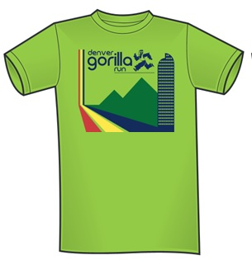
(please circle size)

(please circle size)

Donations:

Make a contribution to The Mountain Gorilla Conservation Fund & save a gorilla!
□ $10 □ $25 □ $50 □ $100 □ Other_____

Donations to MGCF are tax-deductible.

Payment Information:

□ Cash
□ Check (made payable to MGCF)
□ Credit Card* (Visa, Master Card, Discover or AMEX)

Total Amount: $

*Credit card processing fees apply.

Waiver:

Acknowledgment and Assumption of Risk and Release: In consideration of my entry, I intend to be legally bound for myself, my executors, administrator and assignees, do hereby waive and release the sponsors of this event and all persons and agencies connected with this event from all claims for damages, injuries or death, arising from my participation in and the travel to and from this event. I recognize that I may become injured or incapacitated in a location where it is difficult for management to get required medical aid to me in time to avoid physical injury or even death. I also understand and agree that a sponsor may subsequently use for publicity and/or promotional purposes my name and/or pictures of me participating in this event without obligation of liability to me. I also understand entry fees I pay are non-refundable. I have read this waiver carefully and having done so I am signing it voluntarily.

Parent/Guardian
Signature:

Date:

